God’s Armor
In the Letter to the Ephesians, Saint Paul tells us to put on God’s armor to protect ourselves from evil. Saint Paul used the armor and other gear of the Roman army of his time to explain God’s armor of strength, truth, peace, and faith.
Read Ephesians 6:10–17. Then look at each piece of armor pictured here, and give an example of how you use that piece of armor in your own life. To help get you started, we have given two examples.
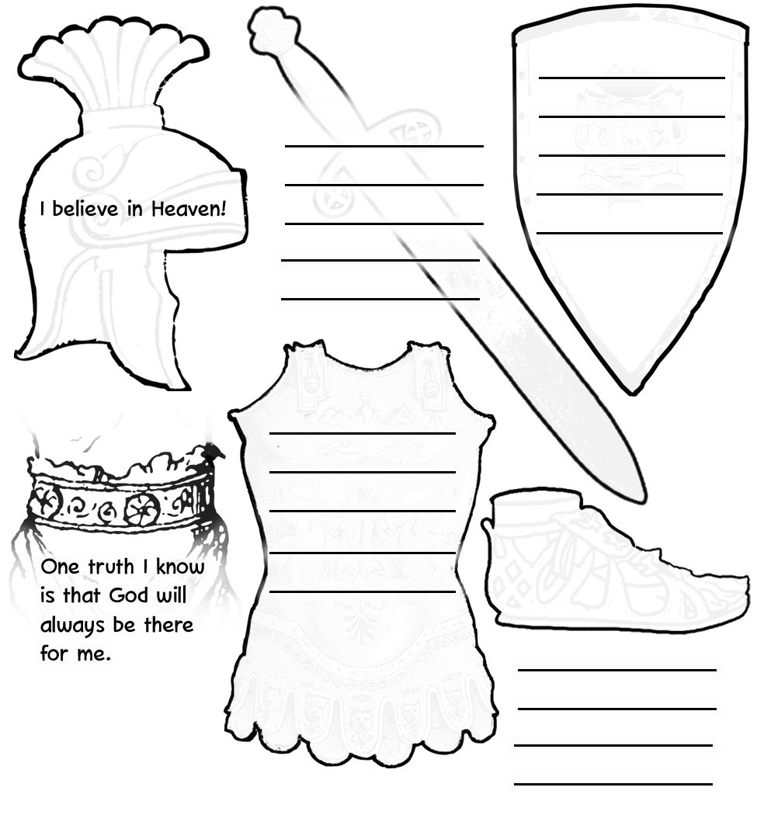

I believe that Jesus is my Lord and Savior!

One truth I know is that God will always be there for me.

Something to consider:
Read the Pray It! article on page 1937. This prayer refers to chapter 3 of Saint Paul’s Letter to the Ephesians, but it is a good prayer to pray anytime. You might like to copy it on a small piece of paper or index card and keep it where you will see it often.

