Chapter 15 Activity:   
Symbols of Jesus’ Suffering

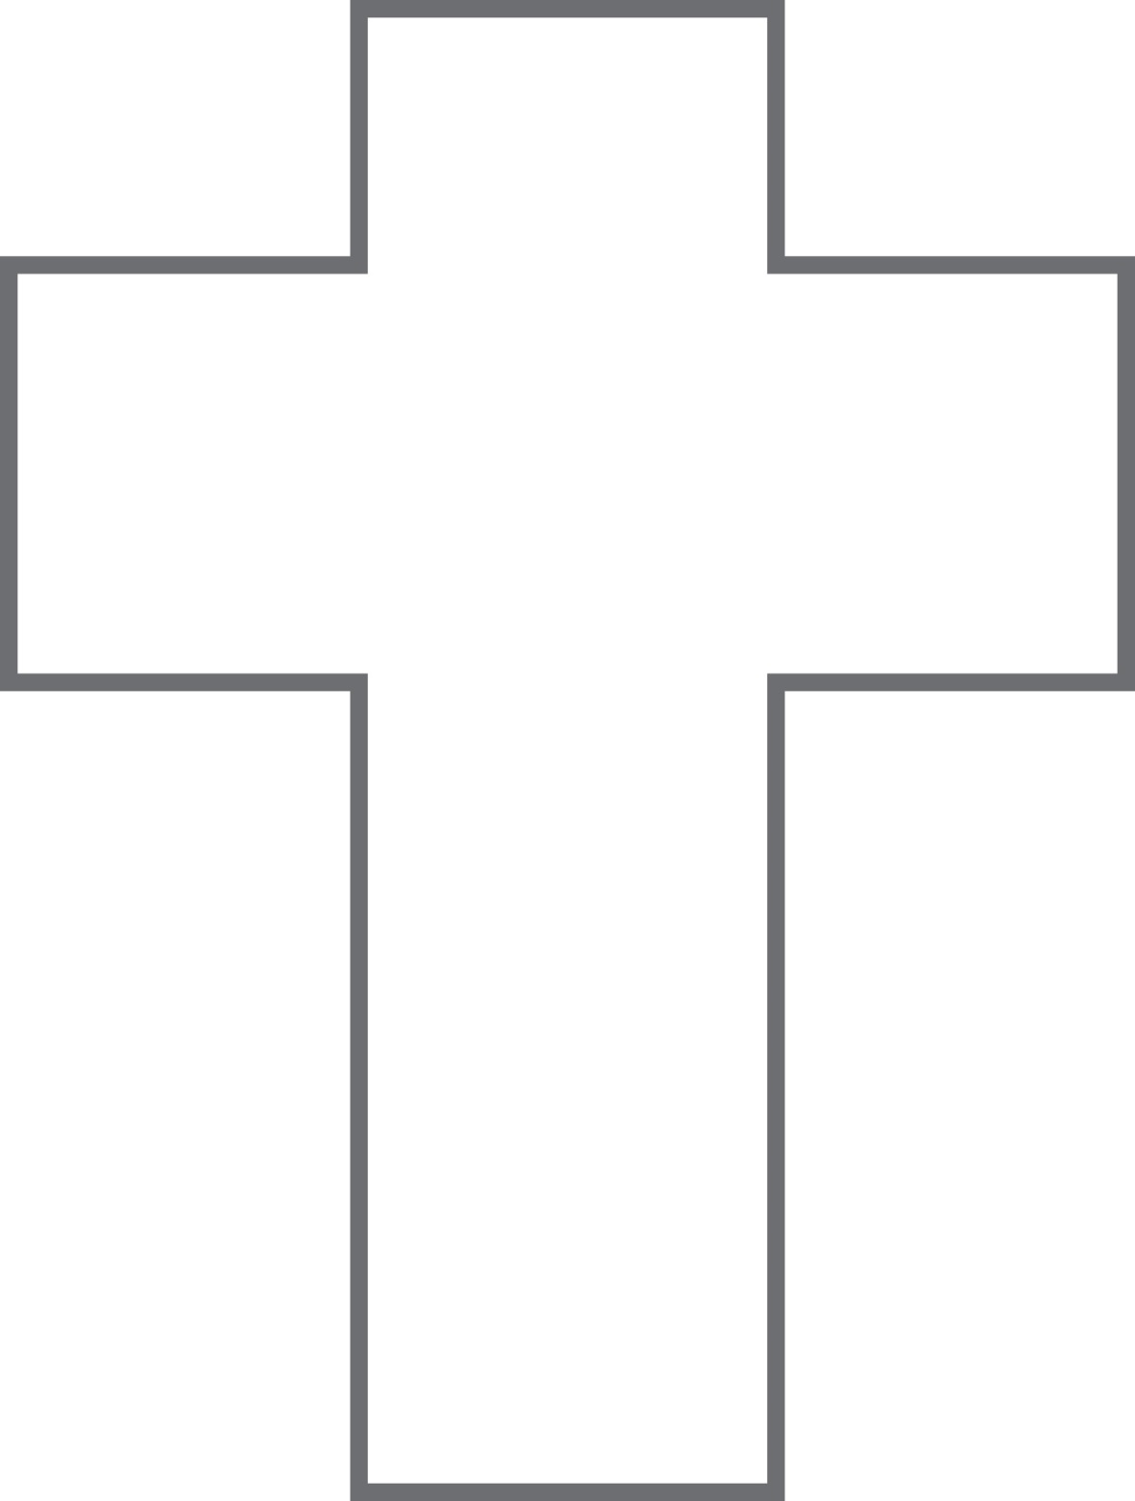Decorate the cross shape below with symbols that represent Jesus’ suffering and death. Refer to the Stations of the Cross on page 165 in the handbook. Choose two of the symbols you have drawn. Tell why you chose each symbol and what each one expresses about Jesus’ suffering and death.

**Symbol:** _________________________

_________________________________

_________________________________

_________________________________

_________________________________

_________________________________

**Symbol:** _________________________

_________________________________

_________________________________

_________________________________

_________________________________

_________________________________