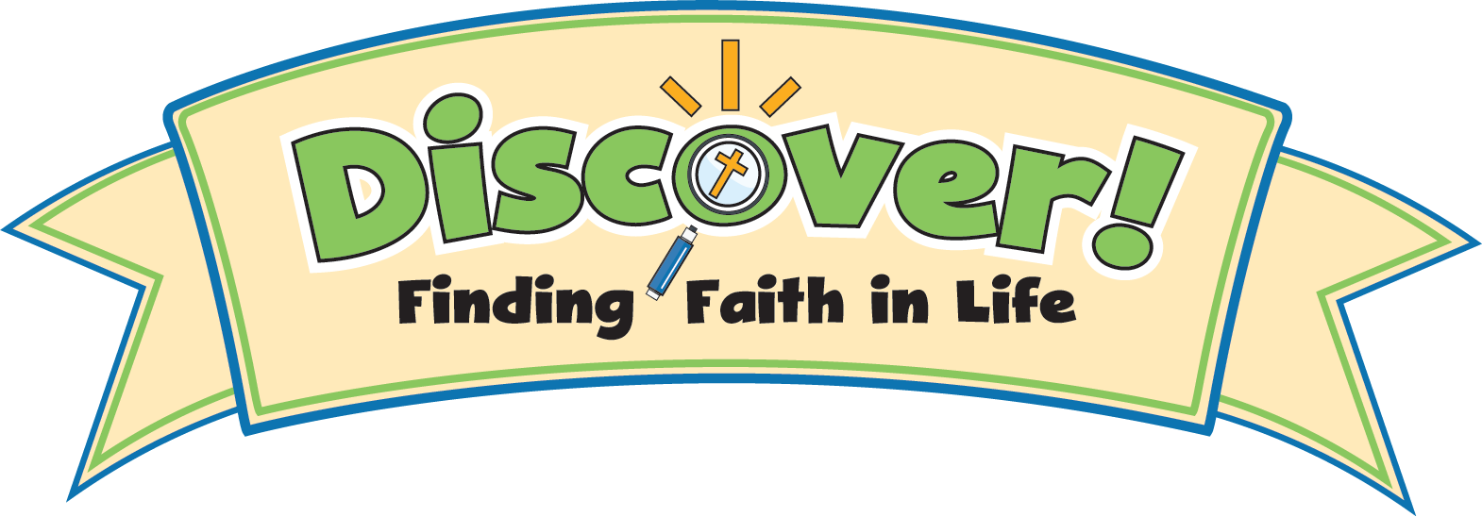

Discover Digital eLearning Form
Please Note: eLearning lessons are available for Grades 1–5 only.

School Name:
School Zip Code:
Coordinator:
Coordinator email address:

Total number of kids in 1st Grade
# of 1st Grade Classes
1st grade Teacher names & email addresses

Total number of kids in 2nd Grade
# of 2nd Grade Classes
2nd grade Teacher names & email addresses

Total number of kids in 3rd Grade
# of 3rd Grade Classes
3rd grade Teacher names & email addresses

Total number of kids in 4th Grade
# of 4th Grade Classes
4th grade Teacher names & email addresses

Total number of kids in 5th Grade
# of 5th Grade Classes
5th grade Teacher names & email addresses



