Missions to North America
With your partner, follow the instructions on this handout to trace the missionary activities in North America during the Age of Exploration.
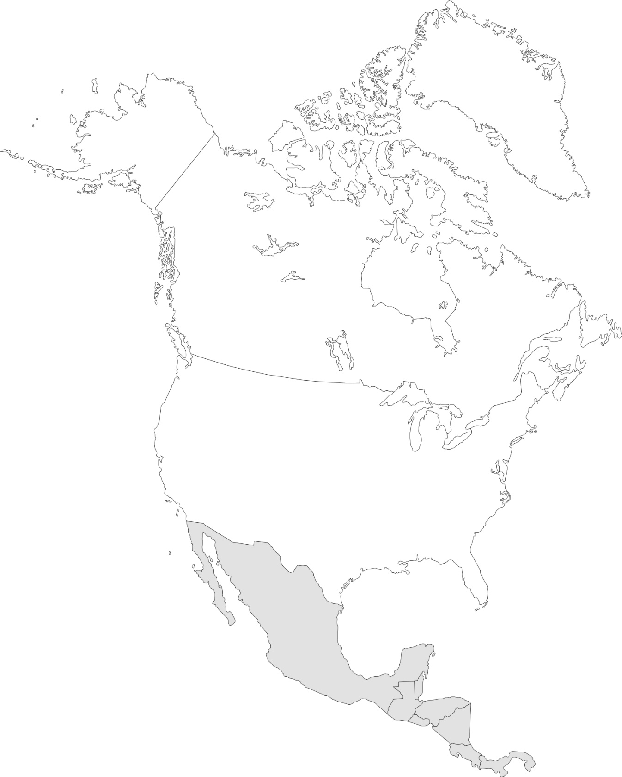
© shutterstock/Volina
1. Use blue to color the region where Spain sent the first missionaries.
2. Use green to color the two states where the Spanish Franciscans founded more than forty missions.
3. Use orange to color the state where the missions protected Spain’s interest in the territory and became economic centers.
4. Use purple to color the region where the French Jesuits established missions.
5. Use a star and the name of the mission to label the first mission city founded in Florida in 1565.
6. Use an X and the name of the mission to label the mission that later became a key battle site in the Mexican-American War.
7. Circle the area where the missions taught the native peoples trades such as carpentry and masonry.
8. Inside present-day California, write the year by which no active missions remained in the state.
9. Use red to color the state where the French missionary presence extended from Canada.

