Altar of Sacrifice

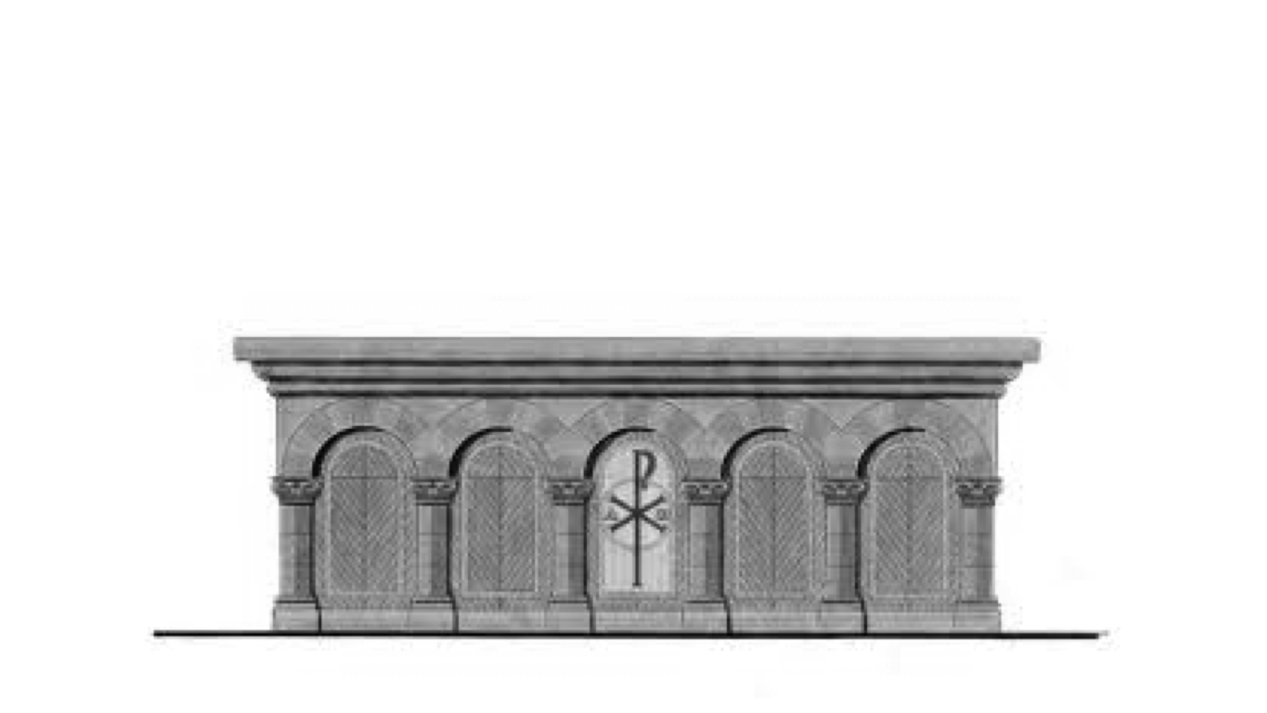

Trust in the LORD with all your heart.
Never rely on what you think you know.
(Proverbs 3:5)

(The quotation on this handout is from the Good News Translation® [Today’s English Version, Second Edition]. Copyright © 1992 by the American Bible Society. All rights reserved. Bible text from the Good News Translation [GNT] is not to be reproduced in copies or otherwise by any means except as permitted in writing by the American Bible Society, 1865 Broadway, New York, NY 10023 [www.americanbible.org].)

