Kings and Prophets
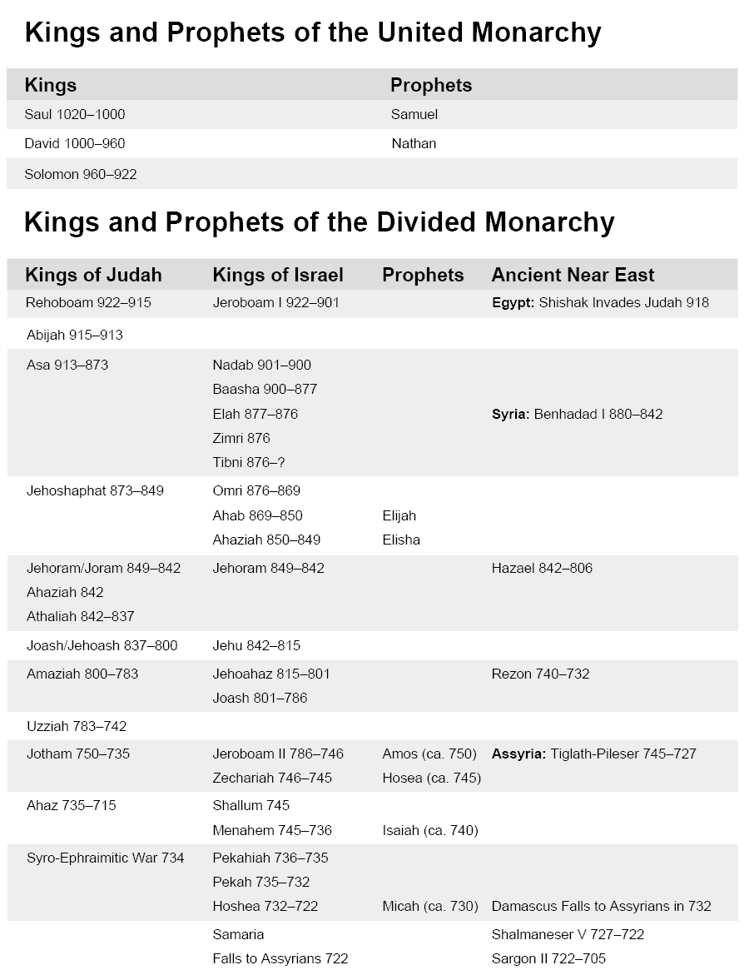
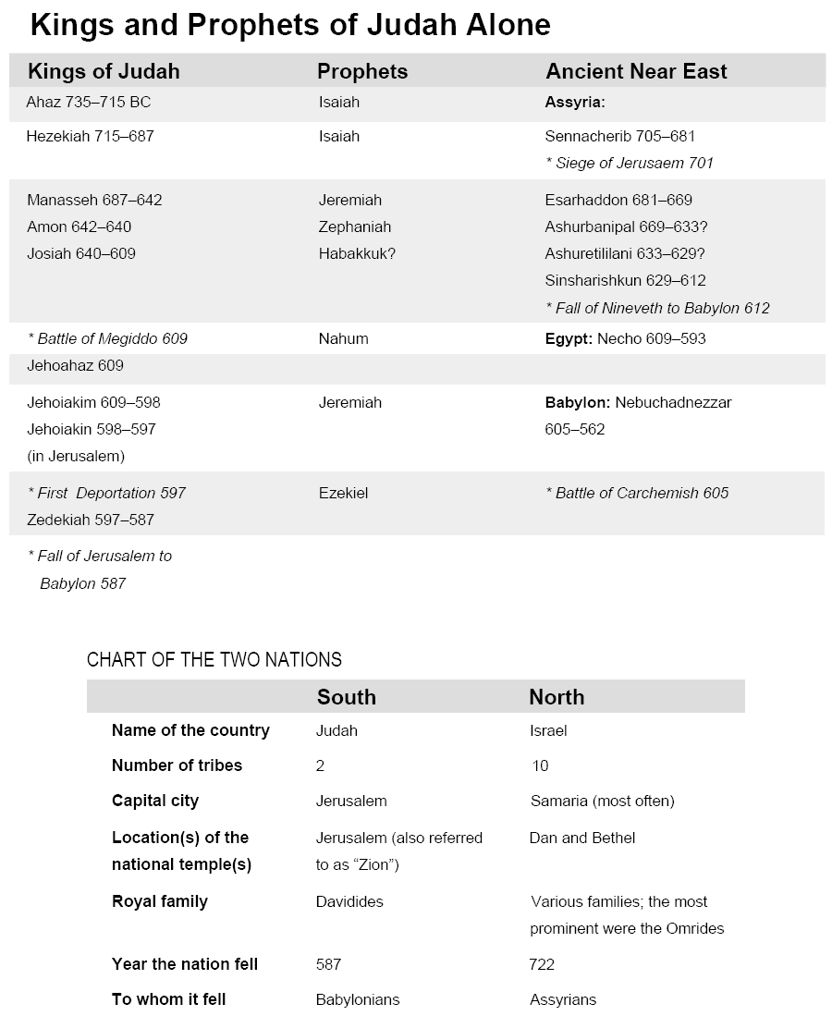

(The charts on this handout are from Encountering Ancient Voices: A Guide to Reading the Old Testament, by Corrine L. Carvalho [Winona, MN: Saint Mary’s Press, 2006], pages 193–194. Copyright © 2006 by Saint Mary’s Press. All rights reserved.)

