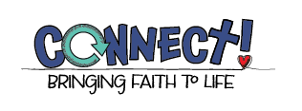
Connect! Bringing Faith to Life Digital eLearning Setup Form
Parish/School Name:
Parish/School Zip Code:
Coordinator:
Coordinator email address:

Year 1 # of Students
Year 1 # of Classrooms
Year 1 Catechist/Teacher names & emails:

Year 2 # of Students
Year 2 # of Classrooms
Year 2 Catechist/Teacher names & emails:

Year 3 # of Students
Year 3 # of Classrooms
Year 3 Catechist/Teacher names & emails:

