The Goodness, Blessedness, and Beauty of the Created World
As you view the class PowerPoint, consider the following questions. You will have time to write your responses after the presentation has concluded.
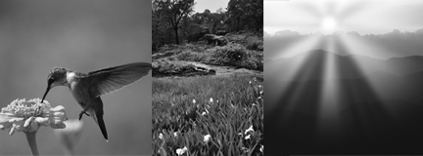
1. Which image is most beautiful to you? Why?
2. Which image would be most helpful to you if you were trying to convince someone of the goodness and blessedness of the created world? How would it be helpful?
3. Which image makes you feel inspired, prayerful, or close to God?
4. “How varied are your works, Lord! / In wisdom you have wrought them all; / the earth is full of your creatures” (Psalm 104:24). What does this quotation mean to you? How has viewing these images helped you to better understand this quotation?

