The Patriarch Family Tree

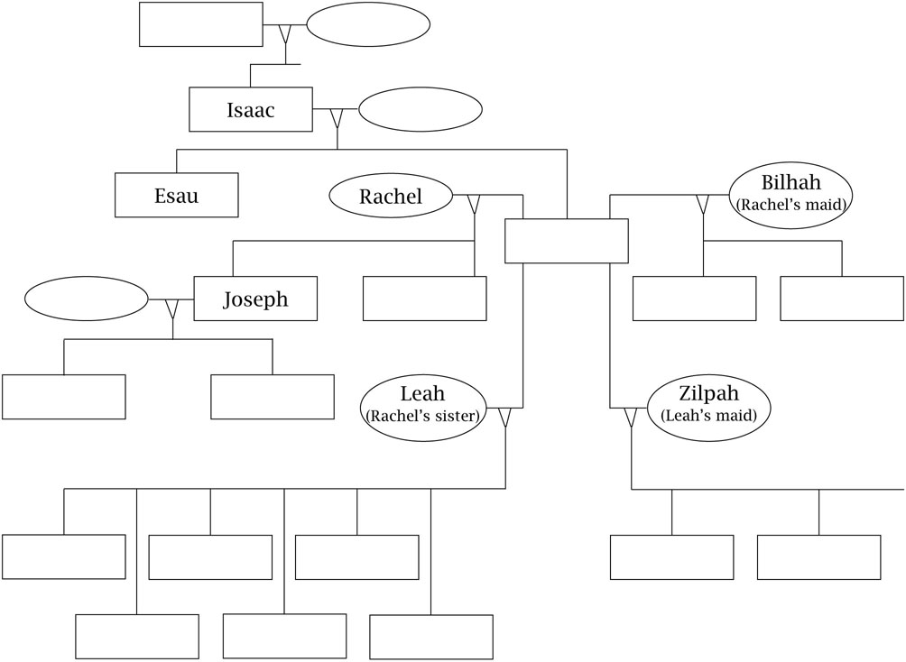

(Adapted from “My Own Genesis,” in Faith Works for Junior High: Scripture- and Tradition-Based Sessions for Faith Formation, by Lisa-Marie Calderone-Stewart [Winona, MN: Saint Mary’s Press, 1993]. Copyright © 1993 by Saint Mary’s Press. All rights reserved.)

