Program Overview
Welcome
Welcome to Go Seek Find: Discover God’s Treasures! We at Saint Mary’s Press are excited to join you in the important ministry of preparing children for the celebration of the Sacrament of Reconciliation and the Sacrament of the Eucharist.
Through this new and unique program, children are led on an adventure of discovery as they explore the rich and beautiful significance of these sacraments in their lives. Go Seek Find will engage and inspire children, creating a spirit of excitement and joy around their journey toward encountering Jesus through the treasures that are the sacraments.
This program was developed with the real needs of children at its center. The core text of this program is the Saint Mary’s Press® Catholic Children’s Bible. By using a Bible designed specifically for them and engaging with the Featured Stories within it, children will explore the sacraments through the biblical lens of Jesus’ life and works and learn more about their faith in language they can understand. They will also experience interactive core activities that bring the chapter lessons to life in a fun and memorable way. And they will learn important information about the sacraments and reinforce this new knowledge through a variety of activities and family learning opportunities offered in the activity booklets that accompany each lesson.
Go Seek Find will help children discover the incredible treasures that are the sacraments. May an ever-expanding awareness of Christ’s presence in our lives be the source of faith, hope, and love for all of us!

With hopes and prayers for every blessing,
The Publishing Team at Saint Mary’s Press

“Ask, and you will receive; seek, and you will find;
knock, and the door will be opened to you.”
(Matthew 7:7)

Program Components
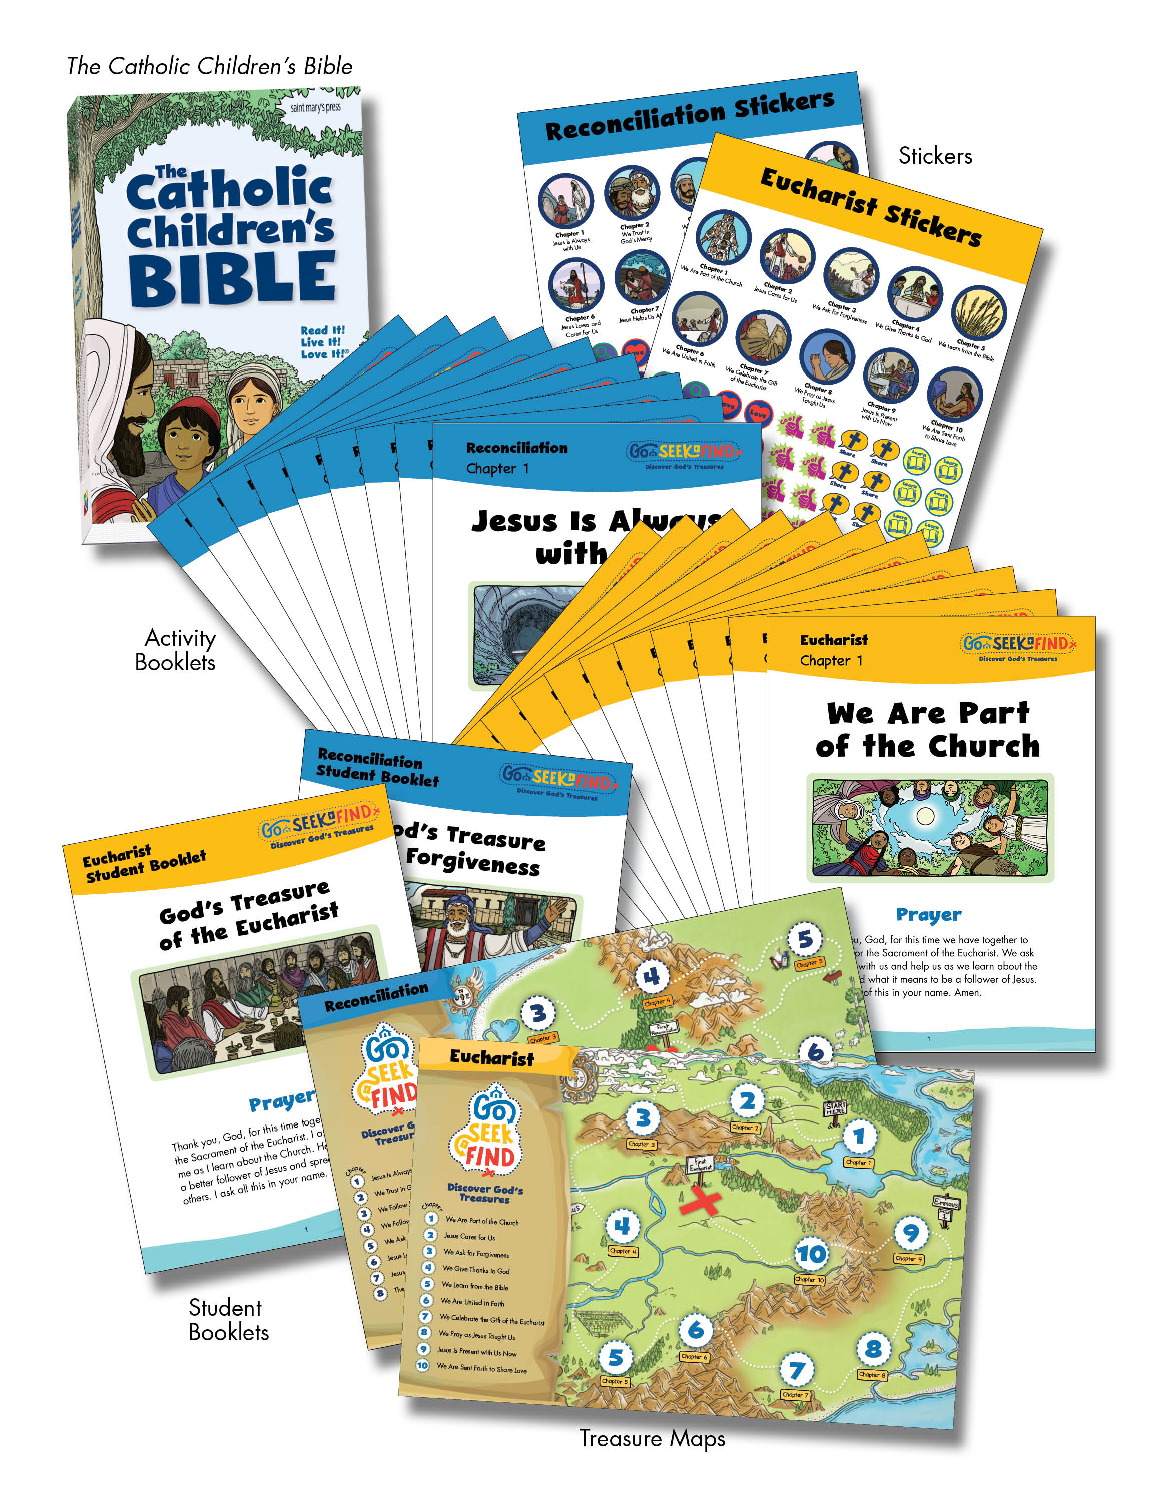

Understanding the Components

Teaching Guide
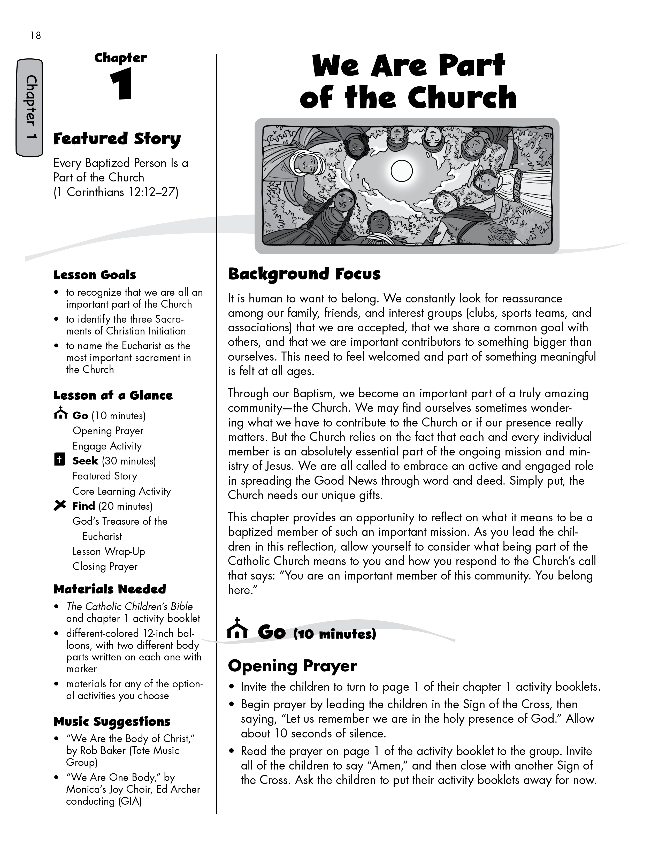
Two Music Suggestions are offered for possible incorporation into the lesson.

Background Focus provides quick, easy-to-read insights about the theme of the chapter.
The Go part of the lesson begins with an opening prayer that is found on page 1 of the activity booklets.
A list of Materials Needed helps you adequately prepare for the lesson.
A list of Lesson Goals shows the key desired outcomes of the chapter.
After the opening prayer, an Engage Activity will spark interest and create excitement in the children.
Jerry, we changed this to “Engage Activity” in the TG. They just haven’t updated the pages below yet.
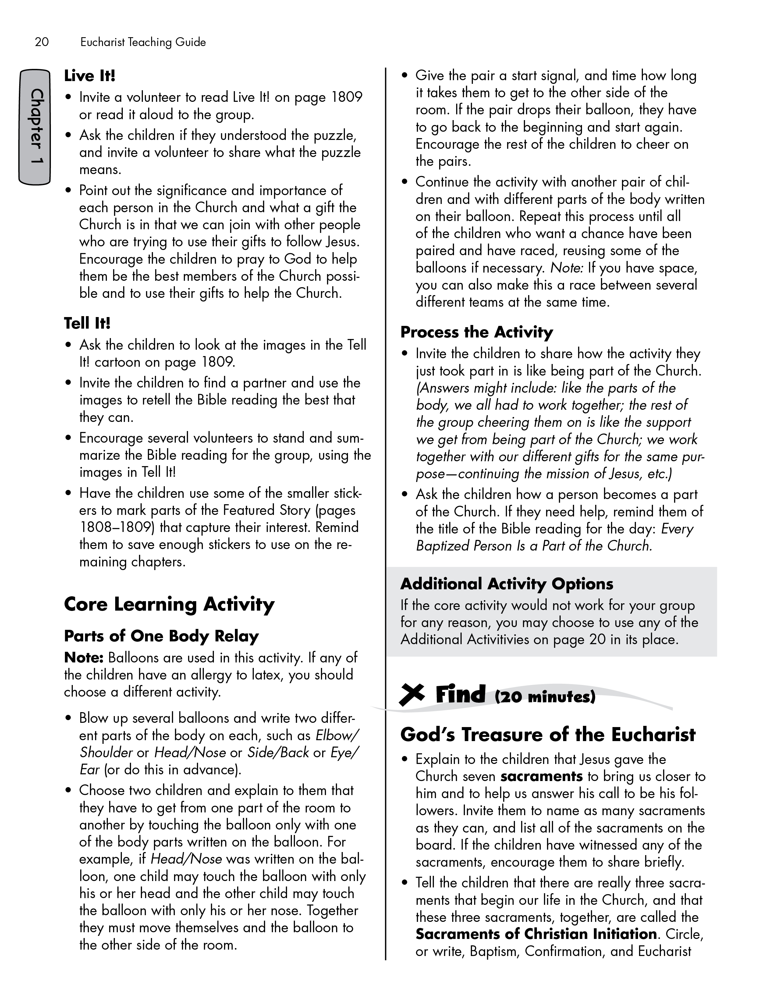
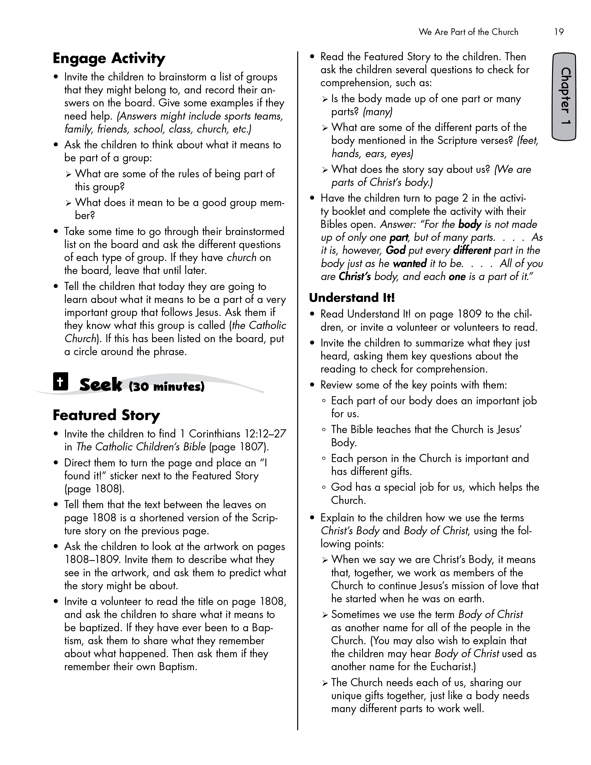
The Find part of the lesson relays key information about the sacrament the children are preparing for.
Each lesson is anchored by a Core Learning Activity. This activity presents an aspect of the chapter theme in a fun, engaging, and memorable way.
The Seek part of the lesson invites the children to interact directly with the Bible and learn key sacrament-related themes through important Bible stories.
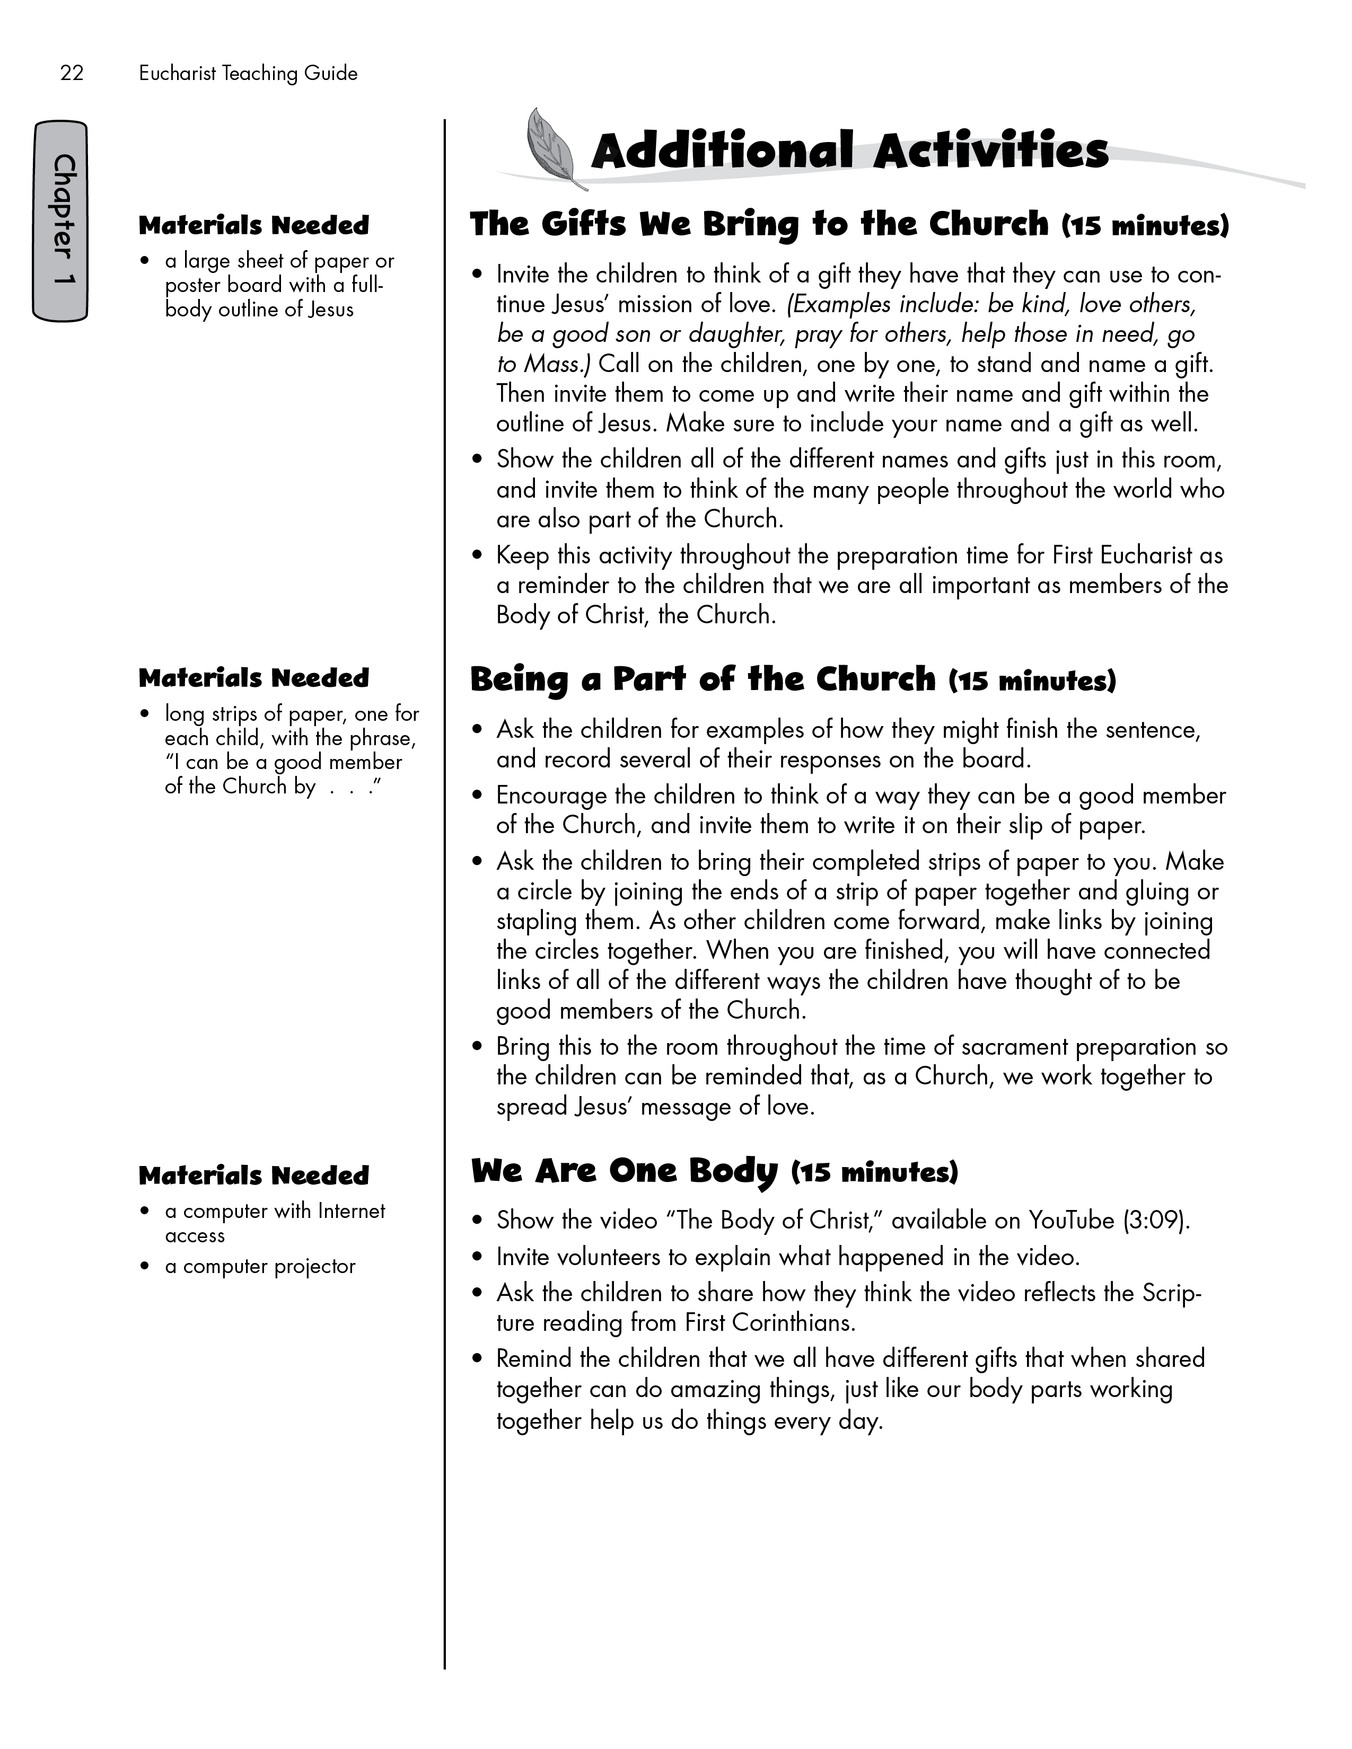
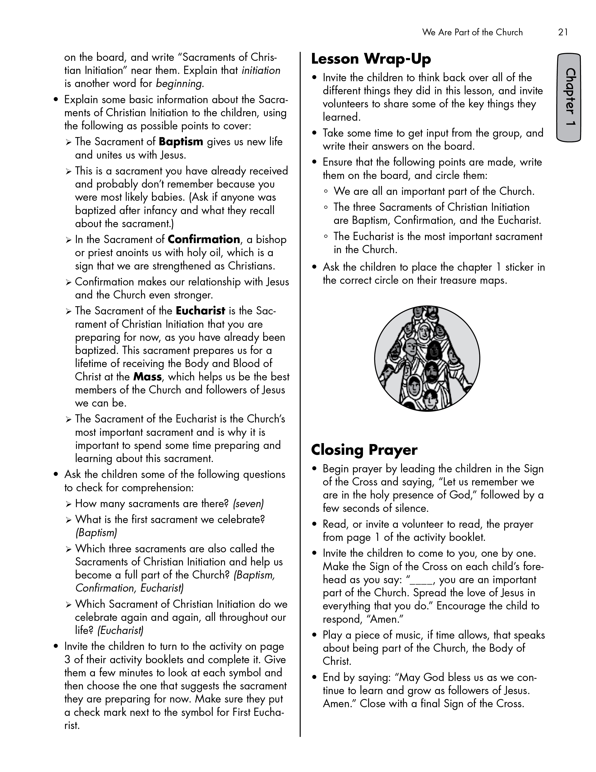
Additional Activities offers substitute options for the
Core Learning Activity. These additional activities also may be used to extend the lesson.
The Lesson Wrap-Up encourages the children to recall what they learned and mark their progress on their interactive treasure map.

Activity Booklets
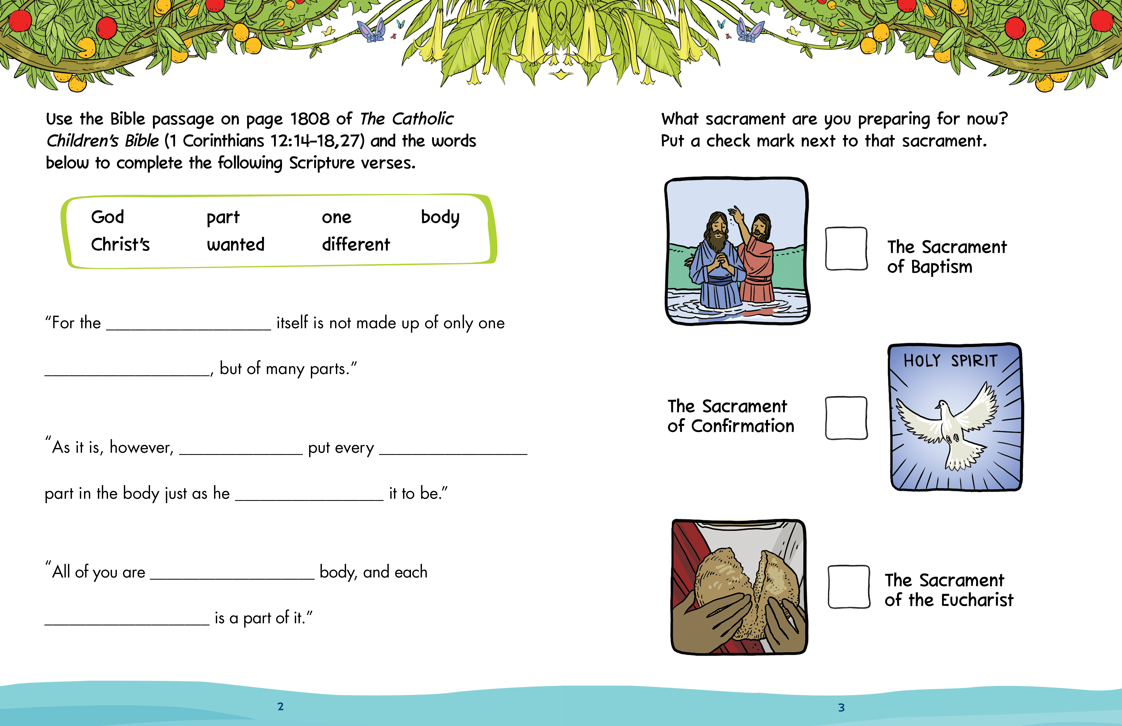
Page 3 (on right) features an activity that relates to the sacrament content the children are learning about in the chapter.
Page 2 (on left) features an activity that relates to content the children are learning about in the Bible.
Each activity booklet begins with a Prayer that is used as the opening prayer for that chapter’s lesson.
The Family Page provides parents with helpful information about the chapter and key ideas to bring the lesson to life at home.

Treasure Map and Stickers
A Treasure Map helps the children track their progress through the chapters in a fun and engaging way that also reinforces what they learned.
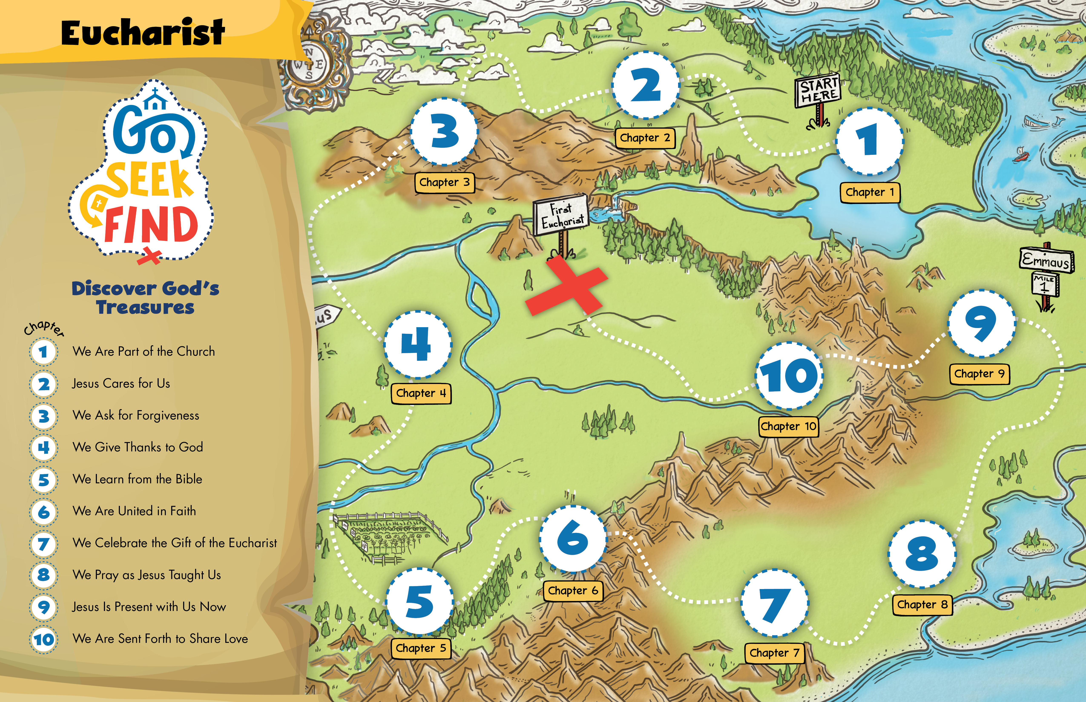
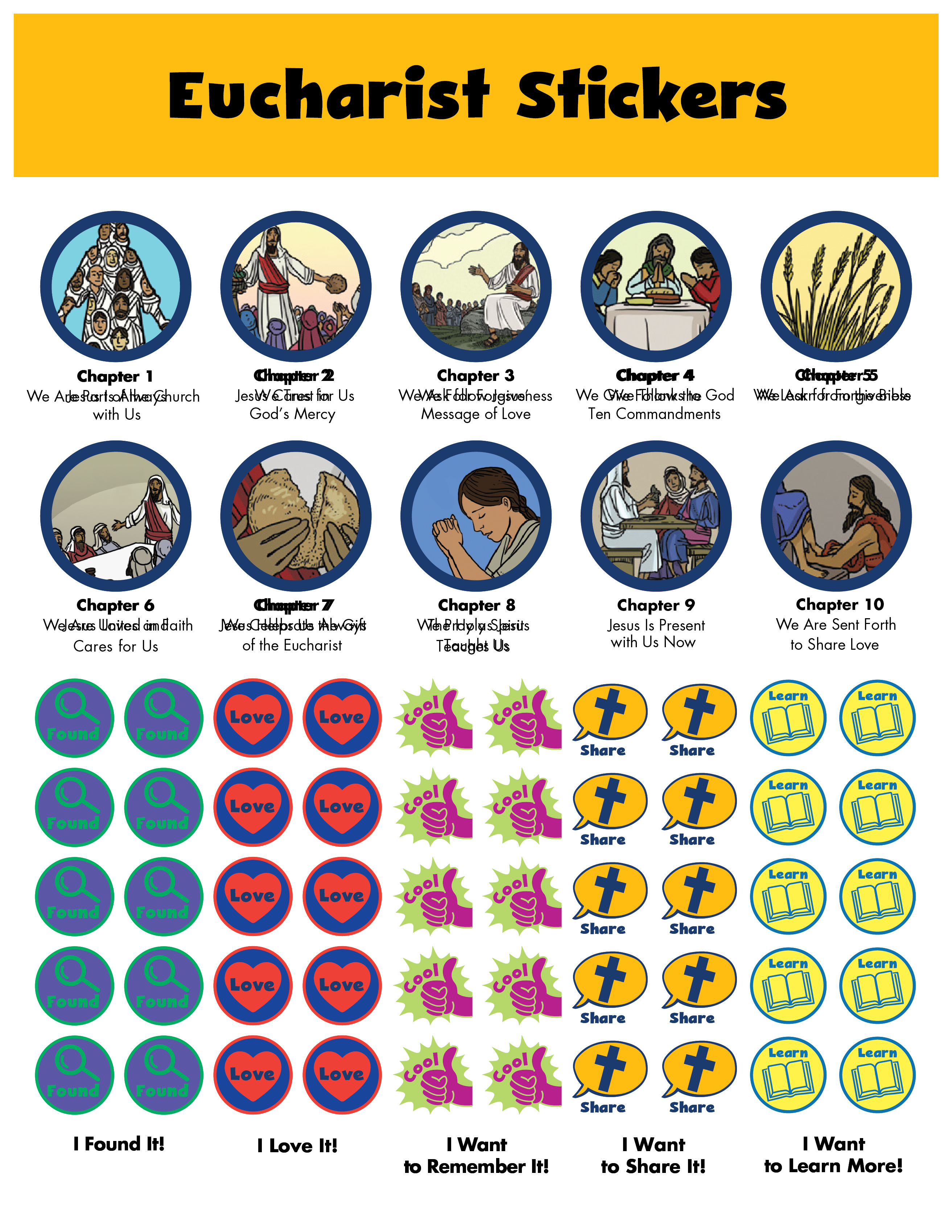
Stickers are also provided to encourage the children to engage with their Bible and mark verses and other content that are meaningful to them.
Stickers are provided that contain key images from the different chapters. The children will use these stickers to track their progress on the treasure map.
Key Elements of the Program

Teaching Guide
The teaching guide divides each chapter into three main sections: “Go,” “Seek,” and “Find.” The “Go” section begins with an opening prayer and continues with a short activity to engage the children in the topic of the day. The “Seek” section involves exploring Scripture related to the sacrament of focus and a core learning activity centered on the chapter theme. The “Find” section provides the children with a deeper look into the meaning of the sacrament and concludes the lesson with a summary and a closing prayer.

Activity Booklets
A fun and colorful activity booklet is provided for each chapter. Although intended for use as supportive group learning activities, these booklets also may be completed at home with the family. They include the opening prayer used for each lesson, two activity pages that support the learning of the chapter, and a family page that offers families background on the chapter topic, strategies to integrate the values of Christian life into family life, and suggested activities related to the lesson to be done at home.

Additional Booklets
The Sacrament of the Eucharist resources include an additional booklet that contains all of the key words used in the program, the Order of the Mass, and the prayers used during the Mass. The Sacrament of Reconciliation resources include an additional booklet that contains all of the key words used in the program, an outline of the Rite, and an examination of conscience.
God’s Treasure of Forgiveness and
God’s Treasure of the Eucharist Student Booklets
God’s Treasure of Forgiveness and God’s Treasure of the Eucharist student booklets provide a child-friendly presentation of the Church’s teaching on the Sacrament of Penance and Reconciliation and the Sacrament of the Eucharist. Each chapter in these booklets connects to a chapter in the teaching guide and reinforces the core content presented in the lessons.

Additional uses for these booklets include:
- leader background, to help leaders present the content in child-friendly language
- a make-up resource for children who miss lessons
- family reading, so parents or guardians can read and discuss each chapter with their child
- a refresher for the children, reviewing key teachings just before receiving the Sacrament of Penance and Reconciliation and the Sacrament of the Eucharist

Treasure Map
Both sacraments have their own corresponding treasure map. This unique and colorful resource is designed to build excitement as the children journey through the various chapters on the way to their first celebration of the sacrament. Using stickers with key images from the Bible stories to be presented in each chapter, the children track their progress on a fun, engaging treasure map as they recall the key themes and lessons offered throughout the program.

Stickers
A sticker sheet is included in the resources for both the Sacrament of Reconciliation and the Sacrament of the Eucharist. In addition to the stickers that allow the children to track their progress on the treasure maps, there are stickers that allow the children to mark Featured Stories or key verses in the Bible that have special significance to them. This immerses the children in the Bible and helps them retain key lessons and messages throughout.
Music Suggestions
Music can add another wonderful dimension to this program. Each chapter includes two song suggestions that correspond to the chapter theme. These songs can be purchased and downloaded online. For a complete list of all of the songs for the program, please see the Go Seek Find resources at www.smp.org/resourcecenter/books/. Of course, you may also wish to add your own favorite hymns or songs such as those popular in your parish community.

Videos
Options for activities that incorporate fun and engaging videos are provided throughout the program. Settings with the necessary technology can use this additional media to further enliven learning. These video suggestions are also included on the Family Page in the children’s activity booklets, so if they are not used within the formal learning environment, they can be enjoyed at home with the family. Quick links to the video resources that are referenced throughout this program are available as part of the online resources for this program at www.smp.org/resourcecenter/books/.

Program Outline: Reconciliation
Chapter Number | Chapter Title | Lesson Goals | Featured Story | Key Words
1 | Jesus Is Always with Us | • to identify that Christ died, rose from the dead, and is with us now  • to recognize that we meet  Jesus in the sacraments  • to express that we confess our sins and are forgiven by God in the Sacrament of Reconciliation | The Risen Jesus  Appears to Mary Magdalene  (John 20:11–18) | sacraments, grace, sin,  Sacrament of Penance and Reconciliation, confession, conversion
2 | We Trust in God’s Mercy | • to recognize that God is a  loving Father  • to identify that God always  forgives us when we are truly sorry for our sins  • to explain that God’s mercy comes to us in the Sacrament of Reconciliation | The Forgiving Father  (Luke 15:11–32) | mercy
3 | We Follow Jesus’ Message of Love | • to identify that we follow Jesus by loving God and others  • to recognize that we can learn about love in Sacred Scripture  • to explain that we can ask for forgiveness in the Sacrament of Reconciliation when we fail to love fully | Love Is the Greatest Commandment  (Mark 12:28–34) | Greatest  Commandment, Sacred Scripture
4 | We Follow the Ten Commandments | • to express that God gave us rules to keep his people safe and happy  • to recognize that the Ten  Commandments are rooted in God’s love for us  • to explain the difference  between a sin and an accident | God Gives His  People the Ten  Commandments  (Exodus 19:16–20:17) | Ten Commandments,  accident
Chapter Number | Chapter Title | Lesson Goals | Featured Story | Key Words
5 | We Ask for  Forgiveness | • to recognize that our sins can be forgiven if we are truly sorry  • to identify that we have more room for love when we are  forgiven in the Sacrament of Reconciliation  • to explain the difference  between mortal sin and venial sin | Jesus Forgives a Woman’s Sins  (Luke 7:36–50) | mortal sin,  venial sin
6 | Jesus Loves  and Cares for Us | • to recognize that Jesus loves and cares for us as a good shepherd cares for his sheep  • to recall that Jesus seeks us out when we stray, and we can return through the Sacrament of Reconciliation  • to explain that in the Act of Contrition, we express our sorrow for having sinned | Jesus Is the Good Shepherd  (John 10:1–18) | penance,  Act of  Contrition,  contrition
7 | Jesus Helps  Us Always | • to recognize Jesus as the Son of God who is with us in times of trouble  • to define ourselves as disciples of Jesus who call on him in the Sacrament of Reconciliation  • to explain that our sins are  forgiven and we are restored to peace when we receive  absolution | Jesus Helps Us in Times of Trouble  (Matthew 8:23–27) | disciple, absolution, conscience
8 | The Holy Spirit Teaches Us | • to recognize that the Holy Spirit is our helper and guide  • to identify that the Holy Spirit helps us in an examination of conscience as we prepare to receive the Sacrament of  Reconciliation  • to review the key words and important concepts of these chapters in preparation for the Sacrament of Reconciliation | Jesus Sends the Holy Spirit to Help Us  (John 14:15–31) | examination  of conscience

Program Outline: Eucharist
Chapter Number | Chapter Title | Lesson Goals | Featured Story | Key Words
1 | We Are Part  of the Church | • to recognize that we are all an important part of the Church  • to identify the three Sacraments of Christian Initiation  • to name the Eucharist as the most important sacrament in the Church | Every Baptized  Person Is a Part  of the Church  (1 Corinthians 12:12–27) | sacraments, Sacraments  of Christian  Initiation,  Baptism,  Confirmation, Eucharist, Mass
2 | Jesus Cares  for Us | • to explain that Jesus cares for us and for all people  • to identify the Eucharist as a way Jesus shows his care for us  • to name the four parts of the Mass | Jesus Feeds a Huge Crowd (John 6:1–15) | Introductory Rites, Liturgy  of the Word, Liturgy of the Eucharist,  Concluding Rites
3 | We Ask for  Forgiveness | • to identify three actions that lead to true happiness  • to explain why we want to be in a state of friendship with God when we receive the  Eucharist  • to articulate that we ask for God’s forgiveness at Mass to prepare for the Eucharist | Jesus Teaches Us How to Be Happy  (Matthew 5:1–12) | Penitential Act
4 | We Give Thanks to God | • to recognize the importance of being thankful  • to identify Sunday as a special day to honor God  • to understand that we pray, give thanks, and praise God at Mass | Thank God for All He Has Done for You  (Colossians 3:12–17) | hymn,  genuflect
5 | We Learn  from the Bible | • to identify God’s Word as the readings and teachings in the Bible  • to describe the importance of preparing our hearts for God’s Word  • to recall that we hear God’s Word at Mass in the Liturgy of the Word | Jesus Want Us to Hear and Accept His Word  (Mark 4:1–20) | parable
Chapter Number | Chapter Title | Lesson Goals | Featured Story | Key Words
6 | We Are United  in Faith | • to express that Jesus wants his followers to be united in faith  • to identify that praying the Creed together is a sign of our unity  • to recognize the core beliefs expressed in the Nicene Creed | Jesus Prays That  His Followers Will Be United  (John 17:9–23) | creed
7 | We Celebrate  the Gift of the  Eucharist | • to recognize that Jesus gave the gift of the Eucharist at the Last Supper  • to identify that the bread and wine become the Body and Blood of Jesus at Mass  • to recall that the Eucharist strengthens us to follow Jesus more closely | The Last Supper (Mark 14:12–26) | Eucharistic Prayer,  consecration
8 | We Pray as  Jesus Taught Us | • to express that the Our Father was taught to the disciples and us by Jesus  • to identify the meaning of the different parts of the prayer  • to recognize that we pray the Our Father at every Mass to prepare us to receive the  Eucharist | Jesus Teaches  Us How to Pray  (Matthew 6:5–13) | Kingdom  of God
9 | Jesus Is Present with Us Now | • to explain that the Risen Jesus is with us today in a special way  • to recognize what occurs  during the Communion Rite  • to identify the proper way to  receive Holy Communion | Two Disciples Meet the Risen Jesus  (Luke 24:13–35) | Holy  Communion
10 | We Are Sent Forth to Share Love | • to describe how Jesus showed us that we should serve others  • to recognize some big and small ways we can serve  others  • to identify the Concluding Rites as the part of the Mass where we are sent forth to share God’s love with others | Jesus Washes  the Disciples’ Feet  (John 13:1–17) | Dismissal
Additional Support Information

Teaching with The Catholic Children’s Bible
Go Seek Find is a unique sacrament-preparation program, as it immerses the children directly in The Catholic Children’s Bible and introduces key themes involved in sacrament preparation through Bible stories. This focus on Scripture builds important biblical literacy as it roots the themes of the sacraments in God’s Word. It is helpful, therefore, that you and the catechists are familiar with The Catholic Children’s Bible in order to help the children become comfortable and confident with its navigation and use. To this end, The Catholic Children’s Bible Leader Guide was created. This invaluable resource will help you introduce The Catholic Children’s Bible to the children, as well as provide you with essential insights into how to help the children to read and understand Scripture. Key articles include:
- “Biblical Literacy and the Teaching of Scripture”
- “Helping Children to Navigate the Saint Mary’s Press® Catholic Children’s Bible”
- “Teaching Scripture to Children”
- “Scriptural Prayer with Children”
- and much more!

Learn more about this helpful resource by contacting your local Saint Mary's Press representative or by visiting www.smp.org.

How to Use This Guide at Home
Some catechetical programs offer a home-preparation model as an option or as the primary way that children prepare for the sacrament. This versatile teaching guide may be used at home as easily as in a larger group setting with multiple learners. Although the guide refers to “children,” all of the lessons can easily be adjusted to be used with one child in a home setting. The instructions and sample language are accessible to anyone in the teaching role, regardless of experience. Multiple activity options also allow a parent to easily incorporate a learning activity into a home lesson. Even other children at home can be included in the activity, turning learning into a fun, family event! Parents also should have access to The Catholic Children’s Bible Leader Guide (see above), as this will help them familiarize themselves with The Catholic Children’s Bible and gain insights into how to help their child read and understand the Sacred Scriptures.

Optional Yearlong Program
Some parishes and schools prefer to devote the entire year to preparation for the first reception of the Sacraments of Reconciliation and Eucharist. Go Seek Find can be adapted to a yearlong program by adding appropriate seasonal and liturgical lessons presented in The Catholic Children’s Bible Leader Guide. Chapter 10 of this guide offers thirteen Scripture-based lessons that include an opening prayer, the reading of a Featured Story, an activity, and a closing prayer, and can easily be added to the lessons in the Go Seek Find program.

Determining a Child’s Readiness for First Reconciliation

Pastoral Discernment
One of the roles of pastors—and, by extension, directors of religious education—is to assess whether children are ready to receive the Sacrament of Reconciliation. When you make the important assessment of readiness, some possible indications to consider include the following:
- The child is baptized.
- There has been catechesis on the Sacrament of Reconciliation.
- The child understands that only intentional acts that do harm can be called “sins,” rather than “mistakes” or “accidents.”
- The child understands that God is ready to forgive our sins and welcome us back to his loving care.
- The child welcomes the opportunity to be absolved by the priest.

Parental Discernment
Parents are key figures in determining a child’s readiness for the sacraments. As the program director, you may wish to conduct individual interviews with parents to discuss their child’s readiness. If parents express concerns about their child’s readiness, it is important to understand their position. In some cases, parents might evaluate readiness differently and expect too much of their child. It may be that the parents themselves do not feel ready for the commitment.
Take care not to make families and children feel that Reconciliation must happen now or never. Just because a child is the right age or in the right grade, it does not mean it is the right time for the child to celebrate First Reconciliation or for the family to prepare the child for First Reconciliation. If a family situation such as divorce or serious illness means that the child’s preparation for First Reconciliation cannot be given proper attention and focus, you, the child’s parents, and your pastor might determine that it is in the best interest of all involved to wait.

Determining a Child’s Readiness for First Eucharist

Pastoral Discernment
One of the roles of pastors and, by extension, directors of religious education, is to assess whether children are ready to receive the Eucharist. When making the important assessment of readiness, some possible indications to consider include the following:
- The child is baptized.
- There has been catechesis on the Sacrament of the Eucharist.
- The child understands that as Eucharist, the bread and wine are no longer ordinary bread and wine but the Real Presence of Jesus.
- The child has a desire to receive Jesus in Holy Communion.
In addition, it can be helpful to assess whether the child participates in the Mass to the best of his or her ability and knows how to receive the Eucharist correctly and reverently.

Parental Discernment
Parents are key figures in determining a child’s readiness for the sacraments. As the program director, you may wish to conduct individual interviews with parents to discuss their child’s readiness. If parents express concerns about their child’s readiness, it is important to understand their position. In some cases, parents might evaluate readiness differently and expect too much of their child. It may be that the parents themselves do not feel ready for the commitment.
Take care not to make families and children feel that it is now or never. Just because a child is the right age or in the right grade does not mean it is the right time for the child to celebrate First Eucharist or for the family to prepare the child for First Eucharist. If a family situation such as divorce or serious illness means that the child’s preparation for First Eucharist cannot be given proper attention and focus, it might be in the best interest of all involved to wait.

Accommodating Children with Special Needs: Reconciliation
Sometimes parents are concerned that their child cannot celebrate First Reconciliation because of a disability or special need. The goal of the Church is to include everyone to the greatest extent possible and to make necessary accommodations to achieve this goal. The Catholic bishops of the United States have provided a resource, Guidelines for the Celebration of the Sacraments with Persons with Disabilities, that may help you anticipate ways to accommodate children with special needs during the celebration of First Reconciliation. The resource may be viewed online at the website of the National Catholic Partnership on Disability, or you may order copies from the USCCB website (click on “Publications” and search for product code 5-425).
The following are a few considerations for accommodating children with special needs during the preparation for, and celebration of, First Reconciliation:
- During activities, preparation classes, orientation sessions, or retreats, children with ADD and ADHD may have to take more frequent breaks in order to focus.
- Children with autism or who are on the autism spectrum may be challenged by some activities and/or the celebration of First Reconciliation. An older sibling or an aide may be able to help at meetings, and you can enlist the help of a child “partner” during the liturgy. Insist on only what is necessary.
- Children with impaired hearing, vision, or mobility may need to sit in front of the church during the liturgy for First Reconciliation. Children with impaired vision or mobility may need assistance getting to and from the reconciliation room or stations.
- Children who are deaf or hard of hearing and who communicate in sign language have particular needs during the celebration of Reconciliation. If a priest who knows sign language is not available to accept their confession, canon law allows someone with impaired hearing to confess through an interpreter of his or her choosing. (The interpreter is then also bound by the seal of confession.) Alternately, the guidelines issued by the U.S. Catholic bishops allow someone with impaired hearing to confess in writing, which afterward should be destroyed or returned to the person (24). To ensure a smooth celebration of First Reconciliation, you will find it helpful to discuss necessary arrangements in advance with any children who have impaired hearing, their parents, and the pastor.
- Children with other disabilities that make communication difficult may need to make their confessions nonverbally. The guidelines of the U.S. Catholic bishops say, “Sorrow for sin is to be accepted even if this repentance is expressed through some gesture rather than verbally” (25).
- You may want to encourage parents of a child with special needs to consult any specialists who are working with their child. These caregivers might have suggestions for other accommodations that can help the child to prepare for and celebrate First Reconciliation.

Accommodating Children with Special Needs: Eucharist
Sometimes parents are concerned that their child cannot receive Eucharist because of a disability or special need. The goal of the Church is to include everyone to the extent possible and to make necessary accommodations to achieve this goal. The following are a few considerations for accommodating children with special needs during the preparation for and celebration of First Eucharist:
- Children with impaired hearing or vision may need to sit in front of the church for the Eucharistic celebration.
- Children with a condition such as cerebral palsy who are not able to place the right hand under the left to receive the Eucharist may accept it in the palm of either hand and bring the hand up to their mouth to consume.
- Children with swallowing issues may need to receive a very small piece of the Host. They may also need to be provided unconsecrated hosts several weeks in advance so they can practice at home with their parents. Note: Be sure to inform your pastor in advance about children who will receive only a piece of the Host or only from the cup.
- Children with gluten intolerance (celiac disease) may receive from the cup only.
- Children with ADD and ADHD may have to take breaks in order to focus or participate in activities or a full-length gathering.
- Children with autism or who are on the autism spectrum may be challenged by some activities and/or the celebration of First Eucharist. An older sibling or an aide may be able to help at meetings, and you can enlist the help of a child “partner” during the liturgy. Insist on only what is necessary.

---------------------------------------------------------------------------------------------------------------------------
The content in this program was developed and reviewed by the content engagement team at Saint Mary’s Press. Content design and manufacturing were coordinated by the passionate team of creatives at Saint Mary’s Press.
The reference and quotation on page 17 are from Guidelines for the Celebration of the Sacraments with Persons with Disabilities, numbers 24 and 25. (Washington, D.C.: United States Catholic Conference, Inc. [USCCB], 1995). Copyright © 1995, USCCB. All rights reserved.
The scriptural quotations in this online resource are from the Good News Translation® (Today’s English Version, Second Edition). Copyright © 1992 by the American Bible Society. All rights reserved.

Copyright © 2016 by Saint Mary’s Press, Christian Brothers Publications, 702 Terrace Heights, Winona, MN 55987-1320, www.smp.org. All rights reserved.

