The Call of Jeremiah
Prophets are people who speak for God and communicate God’s message. Sometimes people listen to God’s message and sometimes they do not. Being a prophet is not an easy job! Read the section “Call of Jeremiah” in Breakthrough! The Bible for Young Catholics (Jeremiah 1:4–10). Use the following steps to help you think about this passage more deeply.

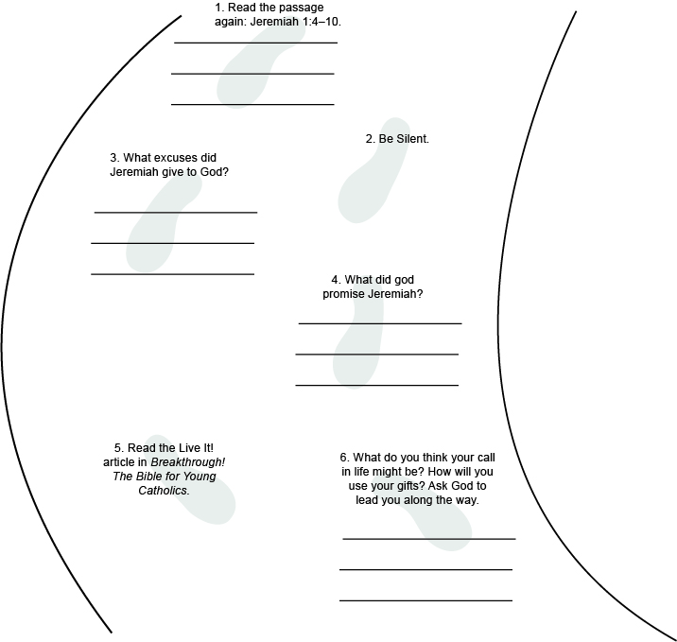
Something to consider:
Look at the art on page 1250. Think about what you see there and consider these questions:

Why is Jeremiah looking up? Look at his facial expression. How do you think he feels?

Jeremiah is surrounded by twinkling lights. Why do you think that is? What could these twinkling lights tell us about God calling Jeremiah?

Look at the reflection questions and answer them here:

Who gives you confidence when you need it? Why do you trust their guidance?

