Using Google Earth
Google Earth is a free, downloadable program that combines satellite images and maps to create a three-dimensional virtual model of the world. The program allows you to search for specific locations and create virtual tours. It also includes supplemental material developed by NASA, Discovery Education, National Geographic magazine, and others.
To get started, download and install the latest version of Google Earth from earth.google.com/download-earth.html. Google Earth is available for PC, Mac, and Linux computers.
Navigating Around Google Earth
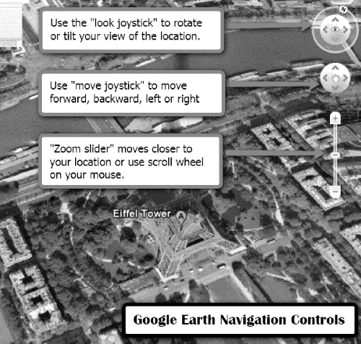
When you first open Google Earth, you will see a large globe. You can “fly to” any place on the globe by typing the name of the location into the “Fly to” search box. Google Earth will zoom into the location on the globe.
Navigation Controls
Move your cursor over the right corner of your screen to use the navigation controls. With these you can tilt the view, move around, or zoom closer to your location. You can also use keyboard controls to navigate Google Earth. For example, pressing the “Ctrl” button and the up arrow simultaneously tilts the view up; pressing the “Shift” button while using the mouse’s scroll wheel also changes the view. Topographical variations can be exaggerated for better viewing by changing the “Elevation Exaggeration” setting to 2 (go to Tools > Options > 3D View tab).
Saving Locations
Use the “Places” panel to save and organize places you visit, addresses, or natural features by zooming in on your location and clicking the “Placemark” icon on the toolbar menu. You can then name the placemark, write a description, and choose a position and altitude for the placemarker icon. To permanently save this point of interest to the “My Places” folder, right-click on the placemark in the viewer and select “Save to My Places.” You can also share placemarkers with others on the Google Earth Community BBS Web site at bbs.keyhole.com/.
You can tour items in your “My Places” listing by selecting the checkbox next to items you want to tour and clicking the “Play Tour” button at the bottom of the “My Places” panel. The tour begins playing in the 3D viewer, which flies to each location and stops for a period of time before flying to the next place on the list.
Exploring Content
The “Layers” feature in Google Earth provides a variety of points of interest that you can select to display over the map. Layers content is created by Google (or its partners) and can be turned on or off by checking or unchecking various layers in the “Layers” panel. You can spend hours learning about the world by exploring this information.
Turn on the “Borders and Labels” layer to see outlines of countries and names of locations.
Turn on the “Terrain” layer to show the elevation of your current view in three dimensions. This feature applies only to natural geographic features, like mountains and canyons, and does not apply to buildings.
Go to “Ancient Rome 3D” in the “Gallery” layer to fly into Rome as it looked in AD 320 and tour famous buildings. You can visit sites such as the Roman Forum, the Coliseum, and the Forum of Julius Caesar. “Rumsey Historical Maps” is also in the “Gallery” layer. Here you can view overlays of maps from historic periods that represent the cartographic art of that time period. Some of the maps fit perfectly in Google Earth while others reveal interesting geographical misconceptions of their time period.
Turn on “Panoramio” in the “Geographic Web” layer to see photos from all around the world. Panoramio community members share their travel photos of various locations, and Google Earth selects images to embed in this layer.
Interacting with the various layers in Google Earth is fun and educational. Check out “360Cities,” “3D Buildings,” and “National Geographic Magazine.”
KML and KMZ Files
KML (Keyhole Markup Language) and KMZ (Keyhole Markup Zipped) are file formats used for modeling and storing geographic features in Google Earth. You can use these files to share places and information with other users. You can find interesting features and places on the Google Earth Community Web site or search for KML or KMZ files in Google’s Advanced Search (under the “File type” drop-down menu). You will need the latest version of Google Earth to view KML and KMZ files.
A KMZ file can be downloaded from the Sacred Destinations Web site (www.sacred-destinations.com/earth/world.kmz) so you can explore interesting religious places in the world. For example, go to witte.dale.googlepages.com/12TribesofIsrael.kmz to download a KMZ file that shows the location of the Twelve Tribes of Israel.
Google Earth Resources
Google Earth User Guide
earth.google.com/userguide/v4/ug_toc.html
Here you will find a guide to learning Google Earth basics, such as navigating the globe, searching, printing, and more.
Google Earth Community
bbs.keyhole.com/
This Web site is a forum for finding KML and KMZ files, asking questions, reading about Google Earth features, and more.
The Google 3D Warehouse
sketchup.google.com/3dwarehouse/
This is an online repository for three-dimensional models that can be viewed in Google Earth, such as Saint Peter’s Basilica, Herod’s Temple, and Egypt’s wonders and monuments.
Google Lat Long Blog
google-latlong.blogspot.com/
This official Google blog offers news and notes by the Google Earth and Maps team.
The Google Earth Blog
http://www.gearthblog.com/
Stay up to date on features and developments from Google Earth.
Google Earth Curriculum Ideas
Bible Geocoding
www.openbible.info/geo/
This site offers the location of every identifiable place mentioned in the Bible, arranged by book and by chapter.
Sacred Places for Google Earth
www.sacred-destinations.com/earth/download.htm
Explore some of the most beautiful and interesting religious places in the world. Each placemark includes a photo, a short description, and links to articles and photo galleries from the Sacred Destinations Web site.
Using Google Earth in Religion Class
witte.dale.googlepages.com/home
This excellent site, created by teacher Dale Witte, gives examples of how he uses Google Earth in his religion class.
Google Earth Lessons
gelessons.com/lessons/
This site offers additional curriculum ideas made by teachers for teachers.

