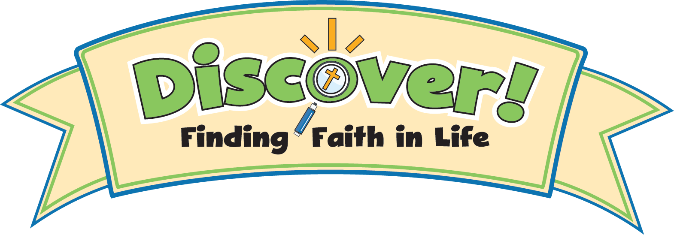

Discover Digital eLearning Form
Please Note: eLearning lessons are available for Grades 1–5 only.

Parish Name:
Parish Zip Code:
Director of Religious Ed:
DRE email address:

Total number of kids in 1st Grade
# of 1st Grade Classes
1st grade Catechist names & email addresses

Total number of kids in 2nd Grade
# of 2nd Grade Classes
2nd grade Catechist names & email addresses

Total number of kids in 3rd Grade
# of 3rd Grade Classes
3rd grade Catechist names & email addresses

Total number of kids in 4th Grade
# of 4th Grade Classes
4th grade Catechist names & email addresses

Total number of kids in 5th Grade
# of 5th Grade Classes
5th grade Catechist names & email addresses



