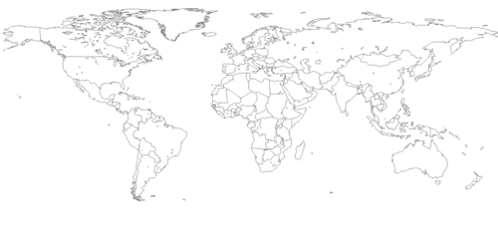If I Ruled the World

If I Ruled the World . . .  What steps would I take to solve world hunger? | If I Ruled the World . . .  What steps would I take to end poverty? | If I Ruled the World . . .  What steps would I take to ensure work equity? | If I Ruled the World . . .  What steps would I take to ensure economic justice?
If I Ruled the World . . .  What steps would I take to solve word hunger? | If I Ruled the World . . .  What steps would I take to end poverty? | If I Ruled the World . . .  What steps would I take to ensure work equity? | If I Ruled the World . . .  What steps would I take to ensure economic justice?
If I Ruled the World . . .  What steps would I take to solve world hunger? | If I Ruled the World . . .  What steps would I take to end poverty? | If I Ruled the World . . .  What steps would I take to ensure work equity? | If I Ruled the World . . .  What steps would I take to ensure economic justice?

