Chapter 40 Activity: First Three Commandments Crossword
Complete the following crossword puzzle to review what you have learned.
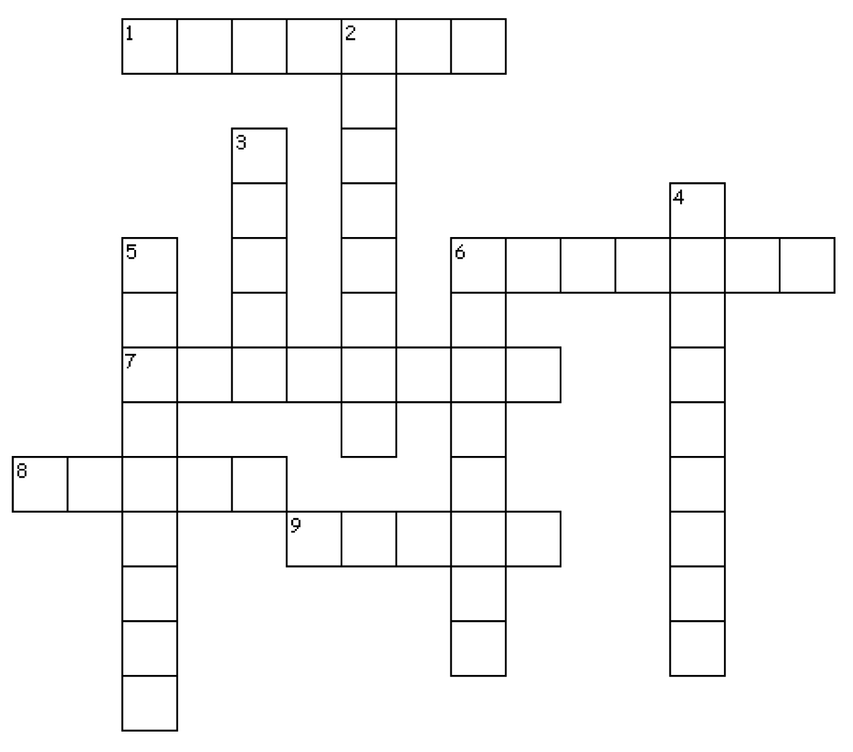
Across
1. _______________, the denial of the existence of God, is a violation of the First Commandment.
6. In the Book of Exodus, the seventh day, a day of rest dedicated to God, is called the _______________.
7. As Catholics, we _______________, or meditate on, holy images and statues as we pray.
8. The _______________ Commandment directs us to love God above everything else in our lives.
9. The Third Commandment tells us we must keep holy the _______________ Day, or Sunday.
Down
2. Making money, possessions, or social status more important than God is a form of _______________ and is a violation of the First Commandment.
3. Saint Peter Claver was born in _______________.
4. Saint Peter Claver was known as the “saint of slaves” in _______________, a major city in Colombia.
5. The Second Commandment tells us we must always treat God’s name with ____________________.
6. Jews observe their Sabbath on _______________.

