Chapter 27 Activity: A Liturgy and Sacraments Crossword
Review what you know about the liturgy and Sacraments by completing the following crossword puzzle.
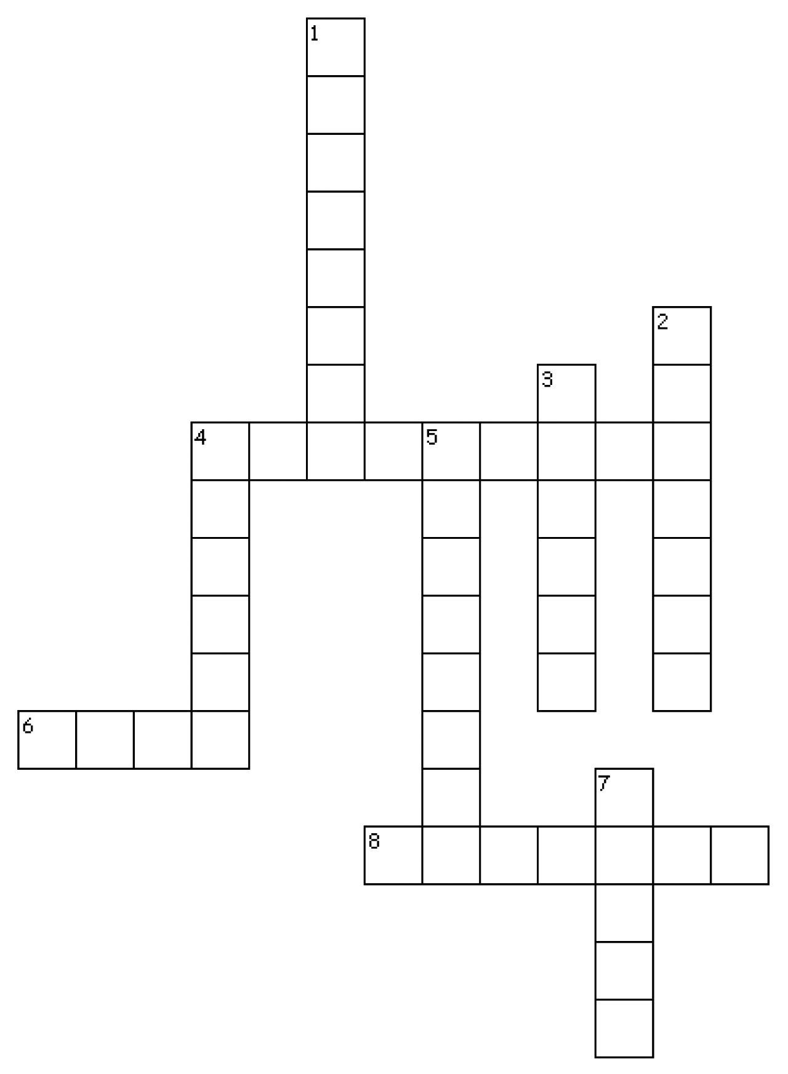
Across
4. Because the Church makes visible the reality of Christ’s presence, it is sometimes called a _____________.
6. Through the work of the _____________ Spirit, the Church makes Christ visible to the world.
8. Things visible to us that help us to recognize what is real but not visible, such as love, are called _____________.

Down
1. The word _____________ means “universal.”
2. The communal, public, and official prayer of the Church is called _____________.
3. The word liturgy comes from a Greek word meaning “work” and “_____________.”
4. The most important day in the Christian calendar is _____________.
5. The People of God gathered to celebrate the liturgy is called the _____________.
7. The most important prayers in the Liturgy of the _____________ are those of the morning and evening.

