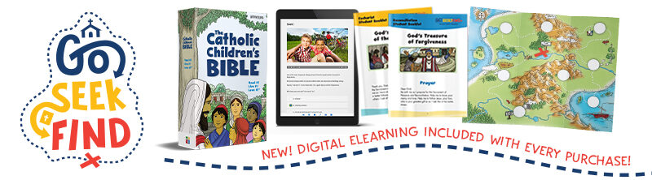
GSF eLearning Option:
A Guide for Parents

- Access the eLearning program with your child’s given credentials, connecting from any device
- 20-minute interactive lessons for self-directed learning
- Age appropriate in presentation, using audio, video, and eLearning modalities
- Unpack the lesson with your child, selecting from a variety of manageable options!

In Preparation:

Have your child use their materials, found in the backpack. In there, you’ll find The Catholic
Children’s Bible (open up to the Scripture to be used in the chapter) and their sacrament
folder. Select the chapter’s leaflet.

Here’s what you can expect from the eLearning chapter…

- We begin with an Opening Prayer, found on the front page of the leaflet.
The prayer is provided on the screen, as well, and an audio clip leads them to pray.

- Next comes a welcome video clip that’s just 1-2 minutes long, to excite and prepare the children to dive into the lesson.
- Now, comes the Scripture Story! The Scripture passage is provided on the screen, as well, and an audio clip will read the passage, allowing your child to either reflect or read along from the screen or from The Catholic Children’s Bible.
- A second video clip comes into play, to help the children along in understanding the meaning of the Scripture and connecting it to their lives.

- Interactive eLearning modalities follow to help your child process their learning. This is all self-directed by audio clips or by reading, dependent on the grade level, asking for response by a series of “clicks.” Older grade levels will solicit typed-in responses, conducive to their learning abilities.
- The next segment connects to the Core Teaching of the chapter (the doctrine).
- More eLearning modalities follow to continue to process your child’s learning
- The chapter comes to a close with a simple wrap up, re-emphasizing the goals of the lesson.
- The lesson experience ends in prayer with the use of an audio clip and the prayer on the screen.

Now, it’s your turn! Here are some fun ways to unpack the lesson with your child:

  - Live links are provided at the end of each lesson in the eLearning program to the Family Page in English and in Spanish, if you don’t have the leaflet handy.
    - Select a family activity to do during the week, together.
    - Use the family prayer at different times throughout your week, such as in the morning, to start the day, or in the evening to end it.
    - Talk about the Person of Faith, a saint who is a true witness of the concepts of faith presented in the chapter, offering an example of how faith is lived.
  - Revisit the Scripture Story before bedtime to discuss and pray together. Extend it into a family ritual each week, engaging all members of the family!
  - Free, online Home Guides provide even more!
    - When using the eLearning option, utilize the 3 questions in the Review at the end of each lesson, provided in the Home Guide. Take these three questions with you to the family dinner table, on a family walk, or Sunday drive! Make unpacking the lesson work with your schedule!
    - If you’d prefer to do the teaching yourself in using the Home Guide, here’s a quick 15-minute video that shows you how to access it and teach from it: https://vimeo.com/399952653. The whole lesson, using the Home Guide, will take approximately 45 minutes in total. If you’d like to use this one-to-one approach with your child, you can, also, break the chapter up into 3 segments, each 10-15 minutes in length, to do at different times during the week, to make it more manageable.

