Setting Up a Blog
What Is a Blog?
A blog is a type of Web site maintained by an individual or a class with written entries or embedded items such as graphics or videos. Entries (called “posts”) are commonly displayed in reverse chronological order. Usually readers can leave comments on each entry.
Blogging can be used for reading and writing, conversations around topics, communicating with a larger audience, or sharing examples from learning portfolios. It can be an effective venue for networked learning. Reading and commenting to one another creates a dialogue and, ideally, encourages persuasive writing and critical thinking.
Blogging Web Sites
You can use many different platforms for creating a classroom blog. The most popular options for free classroom blogs are these:
Edublogs (http://edublogs.org/)
Blogger (http://www.blogger.com/)
WordPress (http://wordpress.com/)
Classblogmeister (http://classblogmeister.com/)
21 Classes (free version limited to ten student accounts) (http://www.21classes.com/)
All these sites have step-by-step instructions for signing up for a blog. You will need to register with an e-mail address and password and choose a name for your blog. There will be a choice of themes and page layouts that can be changed anytime. Be mindful of your school’s policy about posting student work and images online or blogs that contain advertisements. Consider checking with parents and administrators before using blogs in the classroom; you may also want to have your students sign a “Blogging Agreement.”
Identifying the Educational Objective
Before using blogs in the classroom, think about your objective. How will writing, sharing, and posting comments to classmates meet the standards or educational objectives of the lesson? These are some other questions to consider:
What would you like the students to understand?
What kind of authentic task (real-world problem) can you design for the students to demonstrate their understanding?
What supporting activities or tasks need to be completed to help the students construct their understanding?
Identifying the objective will help you to decide such issues as whether each student should have his or her own individual blog, as opposed to having all the students contribute to one shared blog (recommended for new bloggers).
Setting Up User Accounts
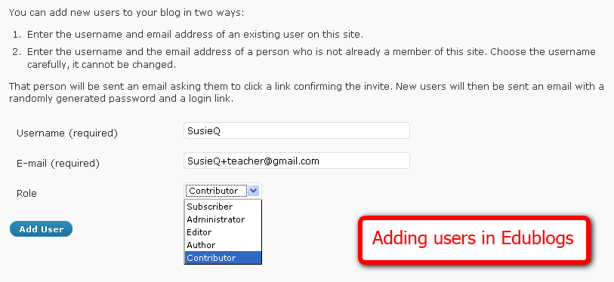
Once the blog account is set up, you will need to create additional user accounts for each of your students. Enter a username for each new user. The username usually appears on the blog accompanying any entries or comments the user posts. Consider using only first names to protect your students’ privacy.
You will need an e-mail address in order to create each student’s user account. One easy way to create student e-mail accounts is to create your own e-mail account using Gmail (Google’s e-mail service at www.gmail.com). If your e-mail address is teacher@gmail.com, all you have to do is add “+studentname” before the @ symbol to make a linked account for a student. Mail sent to teacher+studentname@gmail.com will go straight to teacher@gmail.com, eliminating the need for each student to have her or his own email account.
Different Roles
On Edublogs and WordPress, you can assign different roles to individual users on a single blog account:
Administrator. The administrator (usually the teacher) has access to all the features necessary to manage the blog account.
Editor. An editor can publish posts and manage other people’s posts.
Author. Authors can publish and manage their own posts.
Contributor. Contributors can write and manage, but not publish, their own posts.
Subscriber. Subscribers can subscribe to comments or posts, which are delivered to the subscriber’s RSS reader or e-mail account.
Consider assigning younger students as contributors so editors or administrators can preview and approve the posts before publishing them on the blog for public viewing.
Selecting Viewers
For additional privacy, you can restrict your blog to readers of your choosing. Doing so will force those readers to log in before viewing the blog.

Formatting and Posting
The basic logistics of formatting a blog post are similar among the various blogging platforms. Below is a sample of a typical post:

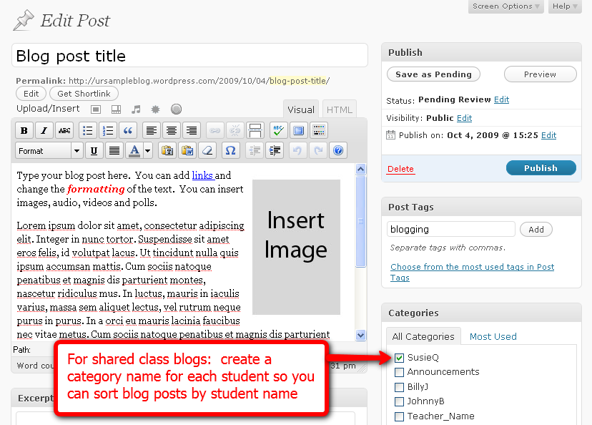

- Choose a descriptive blog post title. Keep it short.
- Write your post in the body area. Consider writing your post offline first so you have time to edit, revise, and check spelling. If you draft your post in Microsoft Word, the WordPress blogging platform’s “Paste from Word” tool removes the word processor’s extra code, which can make editing your post difficult.

- You can apply various formats to the text in your blog, such as color, bold, italic, numbering, bullets, and alignment. Consider using headings, and keep your paragraphs short. Insert hyperlinks to connect to other Web sites and resources.

- Most blogging platforms will allow you to embed a variety of media, such as images, audio, video, and polls. You can edit the HTML code directly to embed other media formats. (Media projects like PowerPoint assignments might need to be uploaded to a file sharing site like www.slideshare.com and then embedded into the blog for viewing.)

- You can “tag” each blog post with several words to indicate the topic. Separate tags with commas.

- For a shared class blog, consider creating a category name for each student so you can sort the blog posts by student name. For example, you might want to check whether students have submitted an assigned number of posts.

- Publish the blog entry or save it for later review by the blog editor.

Encourage the students to maintain high standards of writing; it may help to remind them that blogs usually have a public audience. Student writing should be organized and written with a strong voice. The work should be edited for spelling, capitalization, punctuation, and grammar. Any outside sources should be cited.
Commenting
The type of commenting you want to encourage with an academic or educational blog should be related to the content of the blog post. Blogging is a conversation. Comments in a blog should encourage further discussion and be connected to the author’s point of view. Comments can contain a variety of ideas, share additional links or resources, make a connection with a new idea, share a new perspective, or even challenge the original post.
Encourage the students to avoid dead-end comments such as “Good job” or “I like your post.” Teach the students to use comment starters such as these:
- This reminds me of . . .
- I noticed that you said . . .
- I would like to know more about . . .
I’m not sure that . . .
Consider grouping the students into “learning circles.” The four to five members of this group read and comment on one another’s blogs before the class session. This ensures that everyone receives comments, not just some students.
Moderate and approve all comments before allowing them to be published. This prevents inappropriate comments from being posted on the blog by the students or other Internet users. Remember that comments made by classmates are public to everyone. They should be written with proper spelling and grammar too.
Online Safety
Blogging is a great opportunity to teach about digital citizenship. Teach the students to use only first names and to refrain from identifying their school or location. The students should also avoid using photos of themselves to accompany their usernames. Encourage the students to be kind when commenting and to take blog writing seriously. Remind them to write for their intended audience, especially if the blog is open to the public.
Blogging Resources
Blogs, Wikis, Podcasts, and Other Powerful Web Tools for Classrooms, by Will Richardson. Published by Corwin Press, 2008. ISBN-13: 978-1412959728.

Classroom Blogging, by David Warlick. Published by Lulu.com, 2005. ISBN-13: 978-1411629035.

SupportBlogging! (http://www.supportblogging.com/) Web site to support and promote an understanding of the benefits of educational blogging.

